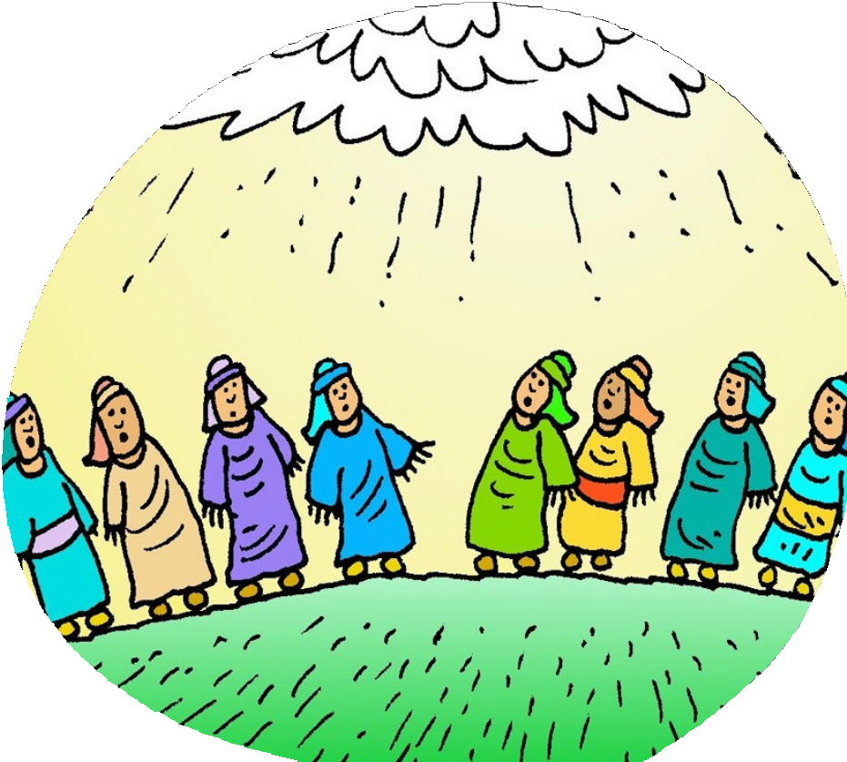

He is Risen!
But what happened next?

What happened next?

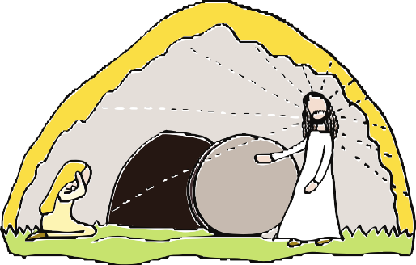
During Holy Week and Easter we hear the amazing story about how Jesus died on a cross and rose from the dead on Easter Day.

That's not the end of the story though! So what happened after that? How did the followers of Jesus really know that He had risen from the dead and what did they do?

In this booklet you can read about the next part of the story from after the empty tomb on Easter Day until Pentecost, when the Holy Spirit filled the hearts of the followers of Jesus.

There are also pictures to colour, word-searches, puzzles and things to think about.

Jesus speaks to all of us. It doesn't matter where we are from, what language we speak or what we have done.

Are you listening to Him?

Contents

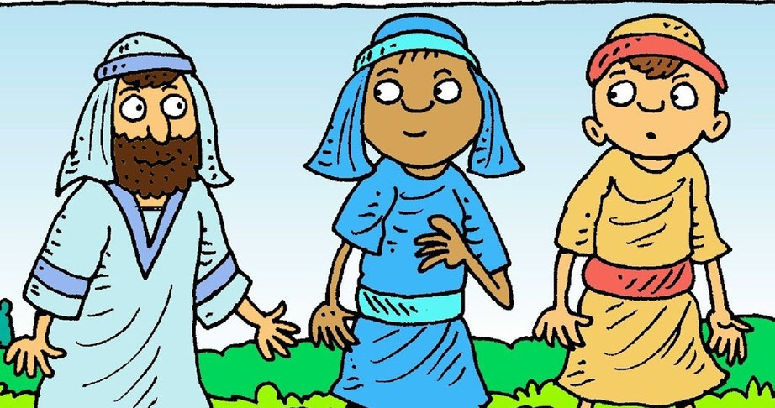
Page 3 The Road to Emmaus

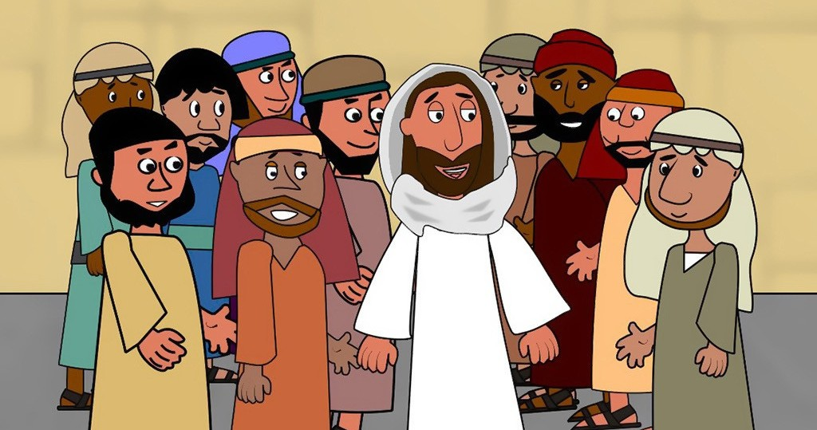
Page 5

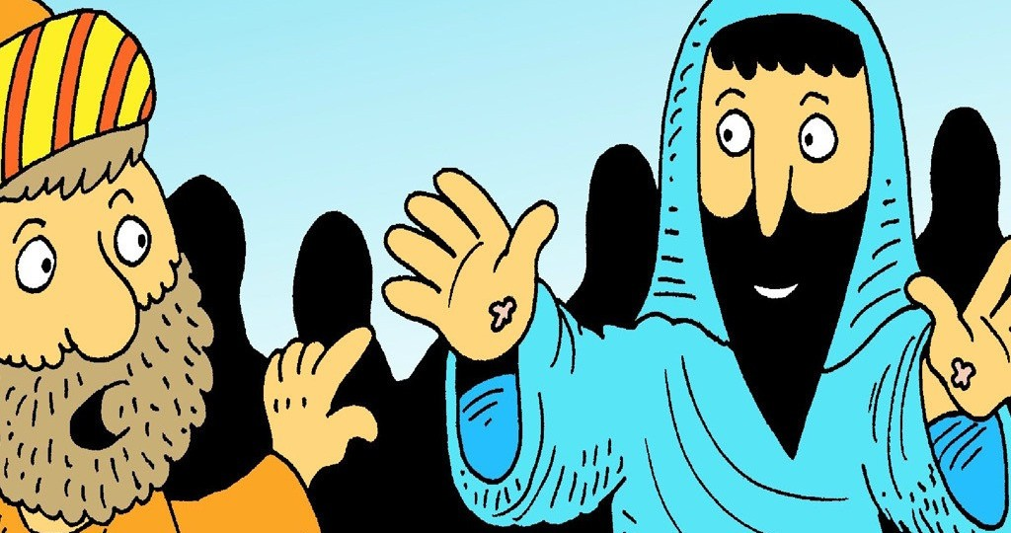
Page 7

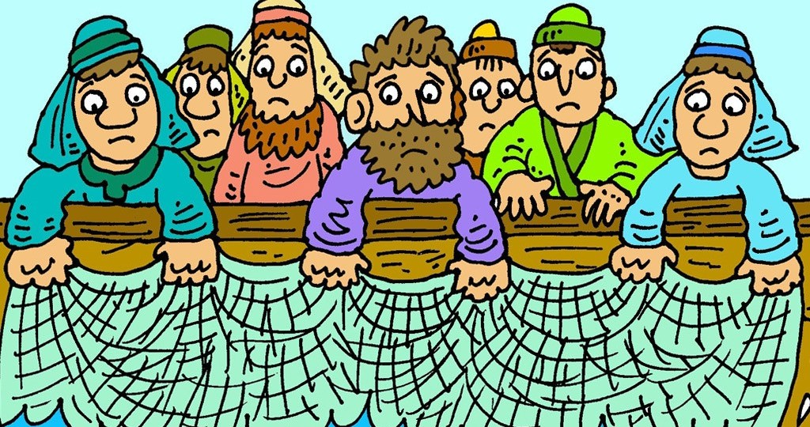
Page 9

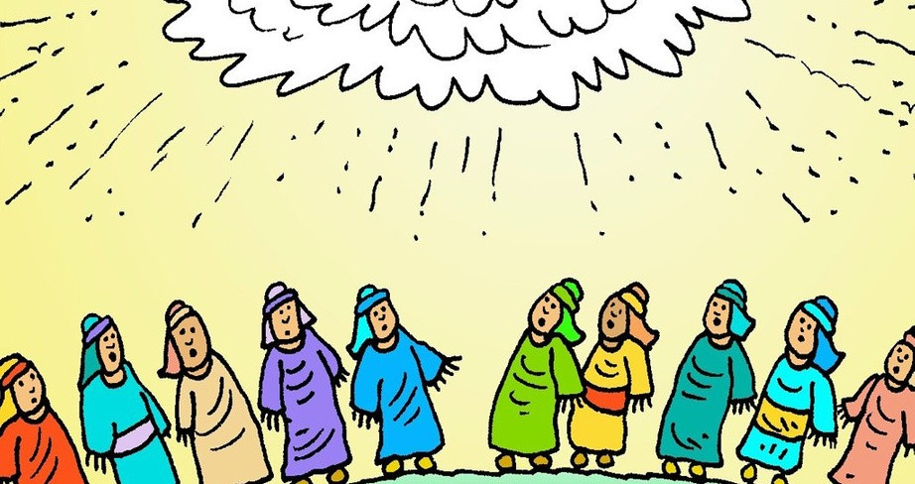
Page 11

Page 13
Jesus Appears

Doubting Thomas

Amazing Breakfast

The Ascension

Pentecost

Story images from www.freebibleimages.com by www.lambsongs.co.nz

The road to Emmaus

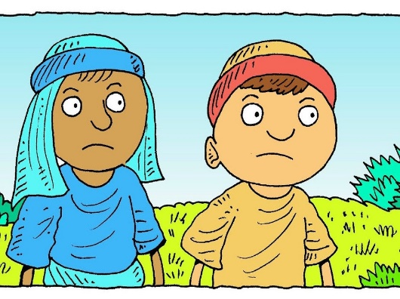
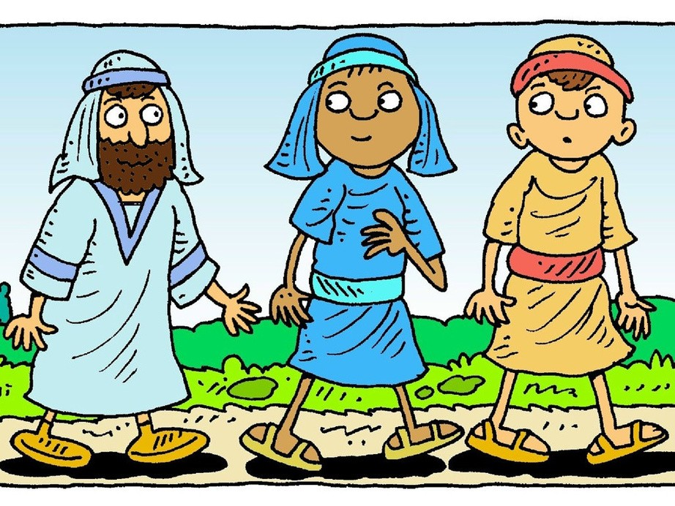
Two of Jesus' followers were going to a village called Emmaus, which was about 11km or nearly 7 miles from Jerusalem. They were very sad and they talked about how Jesus had been crucified. They had thought that Jesus was God's promised son. Now some of Jesus' friends had said that Jesus had risen from the dead! It was so confusing!
While they were talking, a stranger began to walk with them. 'Why are you so sad?' he asked. They told him what had happened to Jesus. The stranger said, 'All these things are written in the Bible!' He told them how everything that had happened to Jesus was part of God's plan. His words gave them hope.

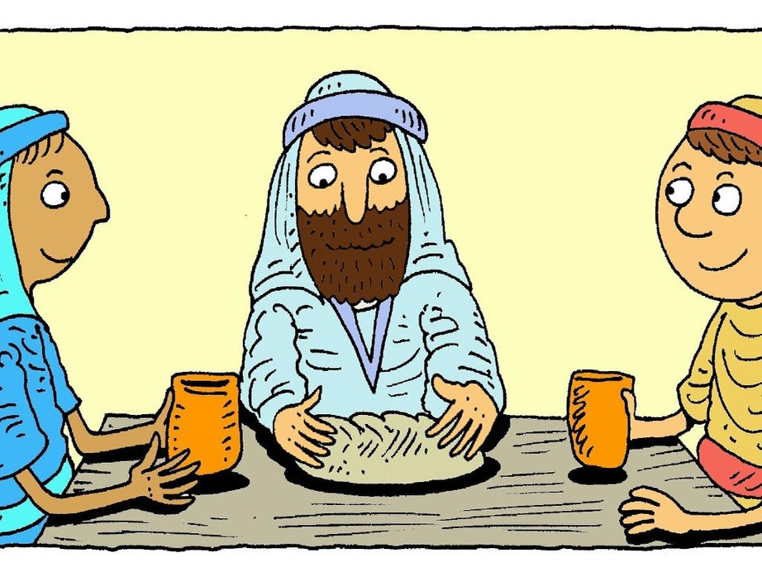
When they got to their house they invited the stranger in for a meal as it was getting late. He sat down to eat with them, took the bread, thanked God and said the blessing; then he broke the bread and gave it to them. Then their eyes were opened and they recognised that the stranger was Jesus!

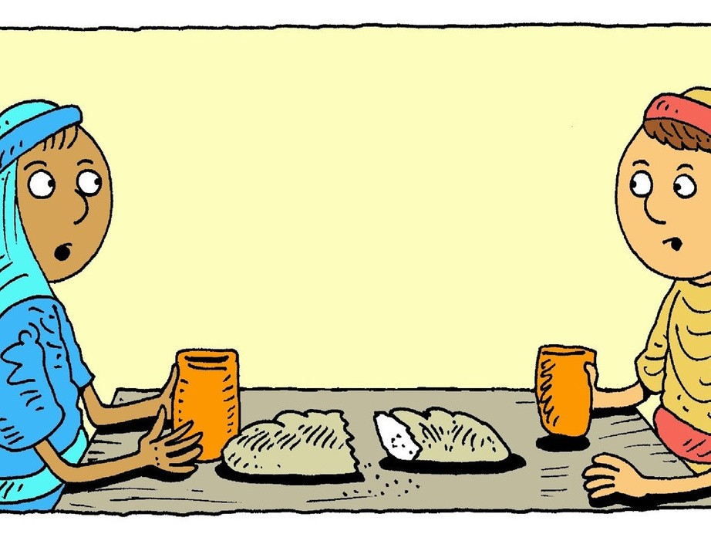
But Jesus disappeared! He had broken the bread, thanking God and they knew that they had seen Jesus! They said to each other, 'Wasn't it like a fire was burning inside us while he talked to us on the road and explained that it was all God's plan!'
Jesus was alive!

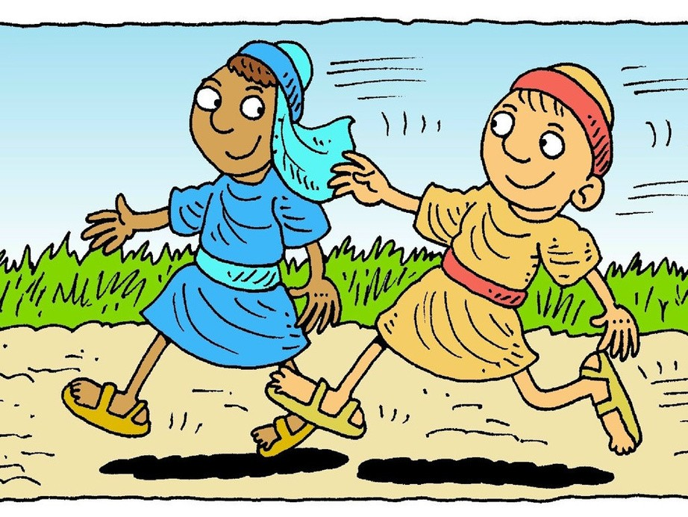
They got up at once and went back to Jerusalem, where they found the disciples gathered together with the others and said, 'The Lord is risen indeed!'
They then explained what had happened to them on the road and how they had recognised Jesus when he broke the bread.
3

Story images from www.freebibleimages.com by www.lambsongs.co.nz

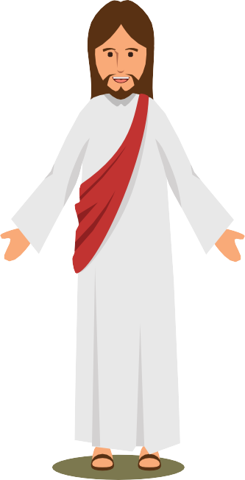

Maze
These two followers of Jesus thought that they had lost him forever. They thought that all hope was lost. Even though they couldn’t recognize Jesus,
he was still with them.
Jesus is with us today and he is at work in our lives, even if we can’t see him or if things seem bad. Jesus gave us ways to remember him by, one of which is the breaking of bread. Jesus is waiting for us to invite him into every area of our lives and as we live closely with him and talking to him regularly, he teaches us about himself.
Help the followers run back
to Jerusalem, through the maze so they can tell the others about what happened to them on the road to Emmaus!
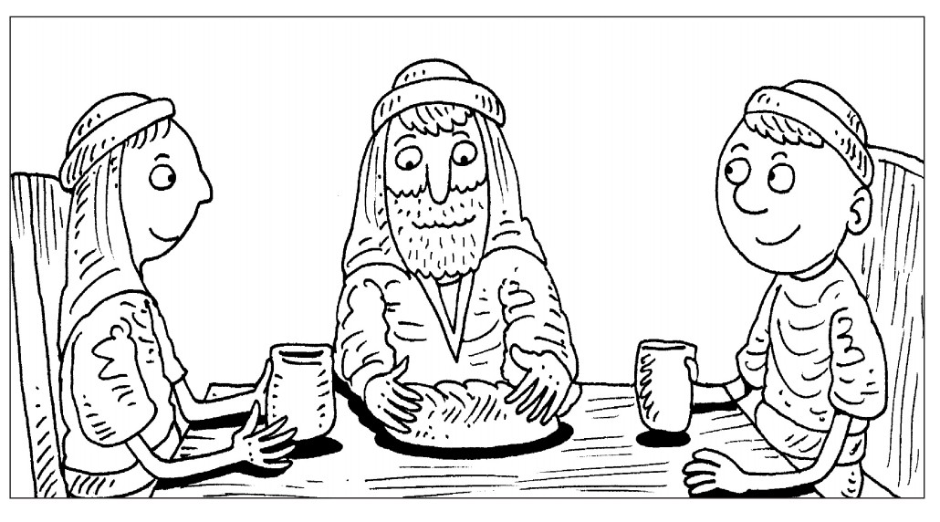
Colour
4

Jesus appears!

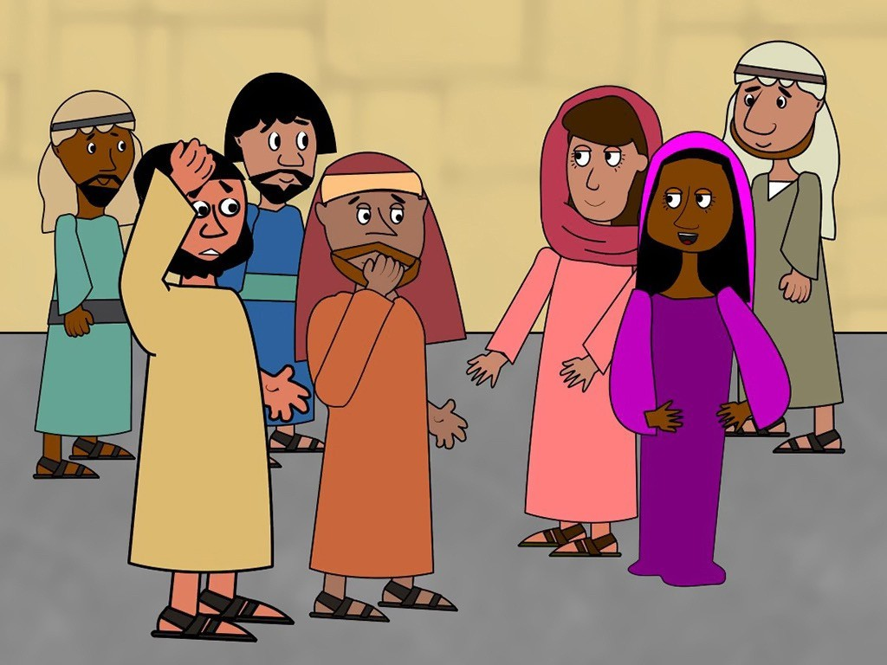
The two followers returned at once to Jerusalem. They found the eleven disciples and those with them, hiding in a room, because they were afraid. They said, 'It's true! The Lord has risen and we have seen him!'
They told them all about what had happened. While they were still talking, Jesus himself stood among them and said to them, 'Peace be with you.'

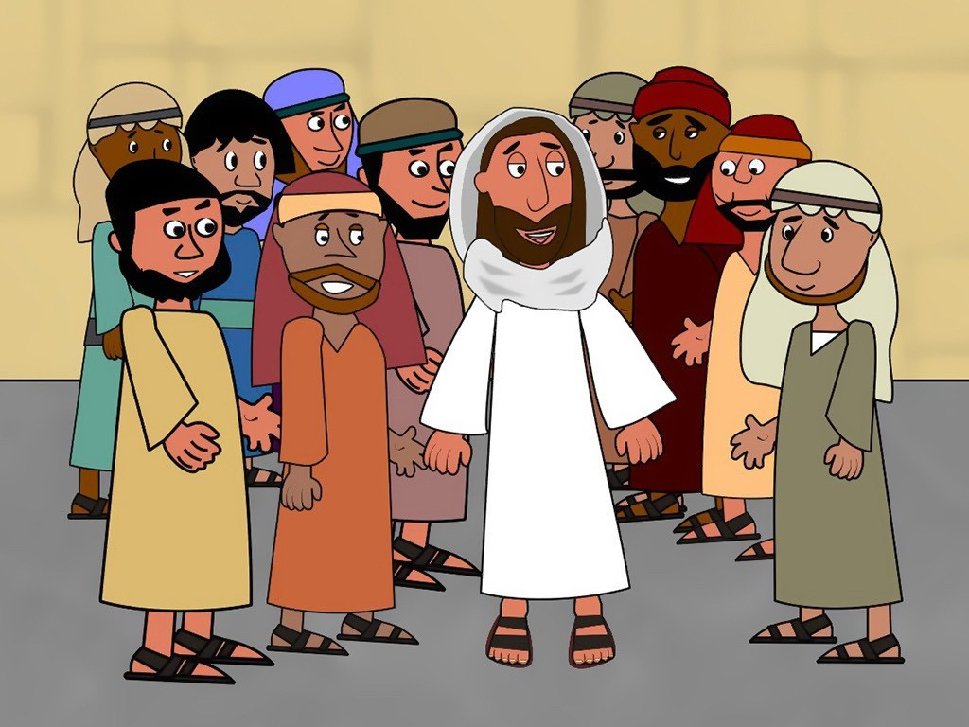
They were startled and frightened and thought they had seen a ghost!
Jesus said to them, 'Why are you frightened? Why do you have doubts? Look at my hands and my feet. It is me!' Jesus said, 'Touch me and see; a ghost does not have flesh and bones, as you can see I do.'
He showed them his hands and his feet and asked them if they had anything to eat.

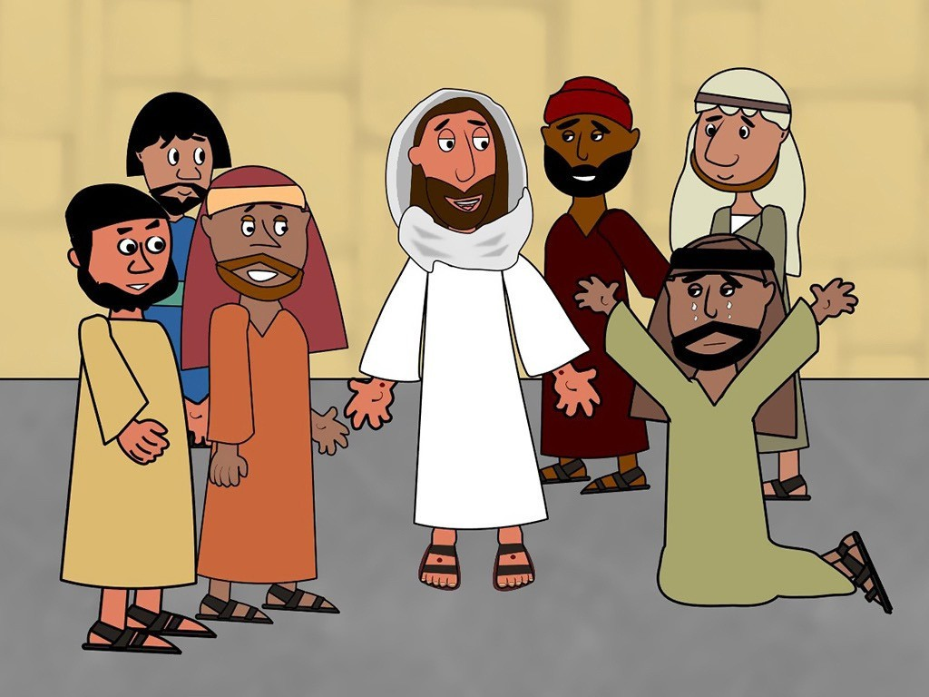
They gave him a piece of broiled fish and Jesus took it and ate it with them. He told them that what happened was all part of God's plan and was written in the Scriptures.
Jesus told them to wait in Jerusalem and He would send them a special present. He told them that God's power will come to them and they will be filled with the Holy Spirit.
5

Story images from www.freebibleimages.com by Sue Bentley

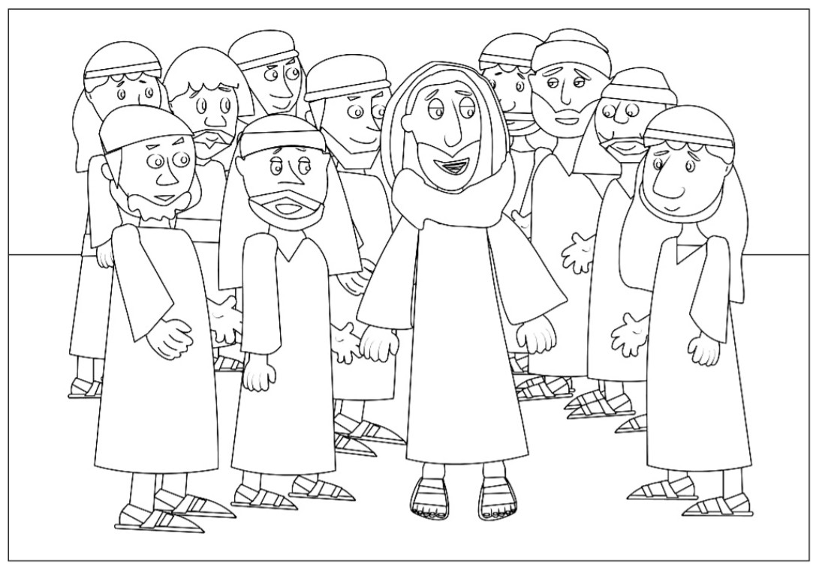
Colour

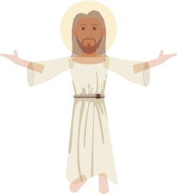
Word Search
JESUS
HANDS FEET SCRIPTURE AMAZED
FRIGHTENED
FISH JERUSALEM APPEAR WAIT
Jesus took time that day to
help the disciples understand that every promise God made and every description of Him in the Old Testament came true with Jesus. We all have questions about Jesus and about the Bible.
If Jesus appeared in this room
now, what would you ask Him about Himself or about the Bible? Ask Jesus to help you understand who He is and what He has done for us.

6

Doubting Thomas

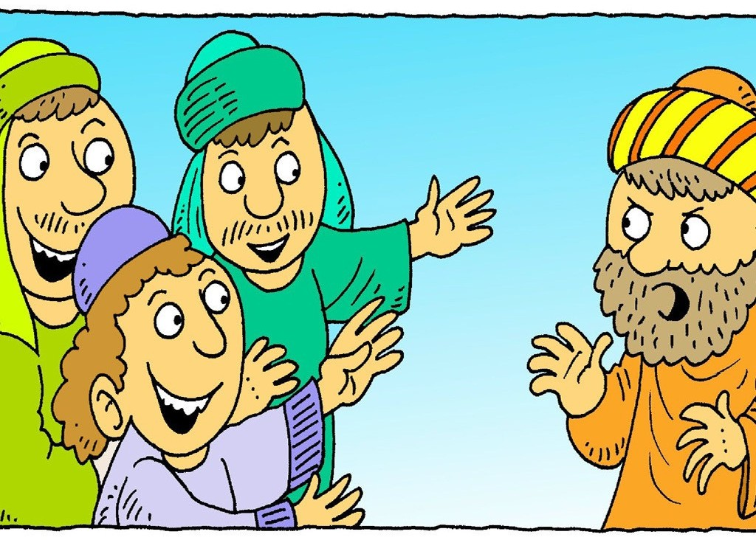
When Jesus had appeared, Thomas had not been there with the others. 'I won't believe it, unless I see Jesus with my own eyes,' he said. When the friends met the next week, everyone was happy, except Thomas. 'How can anyone rise from the dead?' he argued.

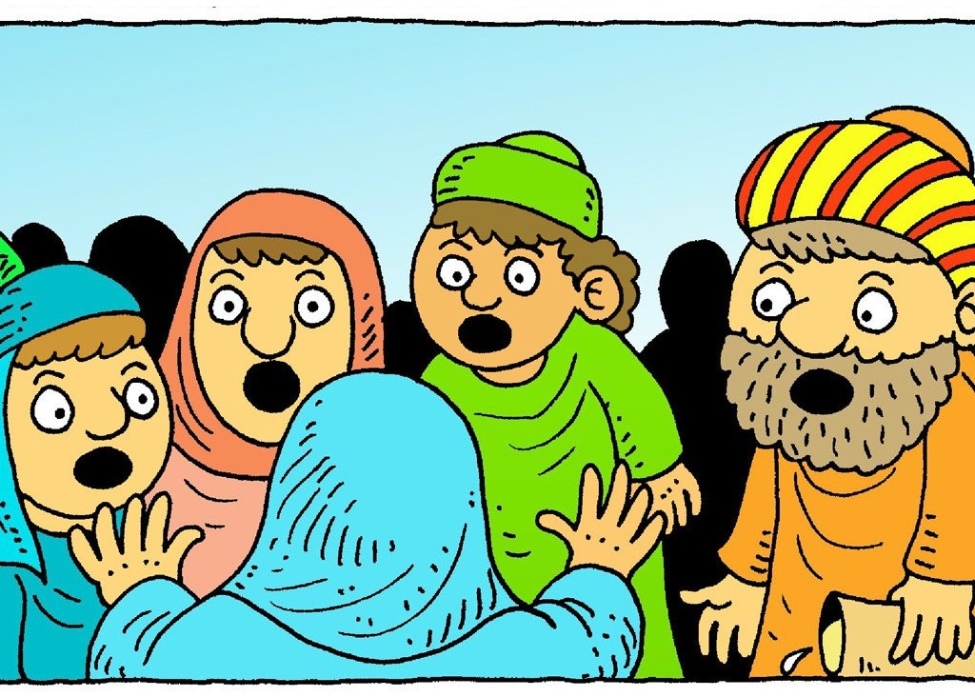
'Unless I see His hands and feet and the marks where the nails were, I will not believe!' he said. Suddenly, Jesus was there, even though the doors were locked! Jesus stood among them and said, 'Peace be with you.'
Everyone was surprised to see Him, especially Thomas!

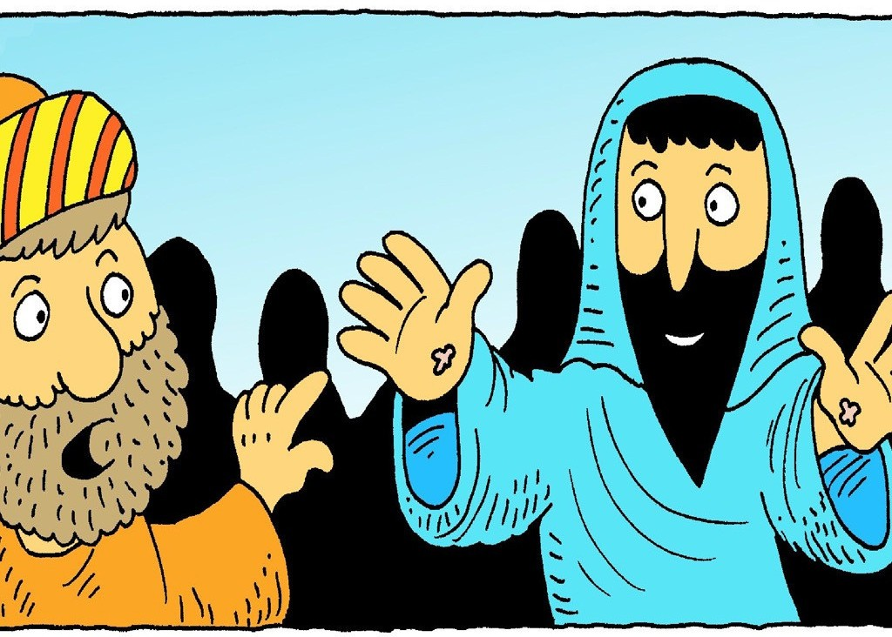
'Don't be frightened,' Jesus said, 'It really is me.' He said to Thomas, 'Put your finger here; see my hands. Reach out your hands and put it in the wound in my side. Stop doubting and believe!' Then Thomas knew that Jesus had risen from the dead and he believed because he had seen Jesus for himself.

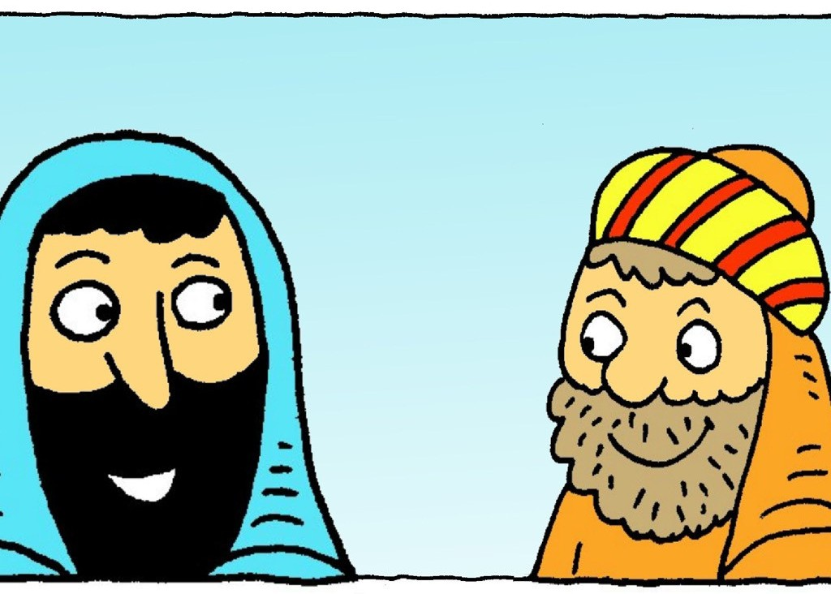
Thomas said, 'My Lord and my God.'
Jesus replied, 'Thomas, because you have seen me with your own eyes, you believe. In days to come those who have not seen me and still believe, will be blessed'.

Story images from www.freebibleimages.com by www.lambsongs.co.nz
7

Even after doubting, Thomas saw Jesus and recognised him, saying 'My Lord and my God' (John 20:28)
How would you recognise Jesus if you met him? What things would he being doing or saying?
How have you recognised Jesus at work in your life before?
For example, answered prayers or other people's kindness

If we, as Christians, are trying to live as Jesus would, how will other people recognise Jesus in us and what we do?

Make
Think of things you could do during the coming week that would help others to recognise Jesus at work in you.

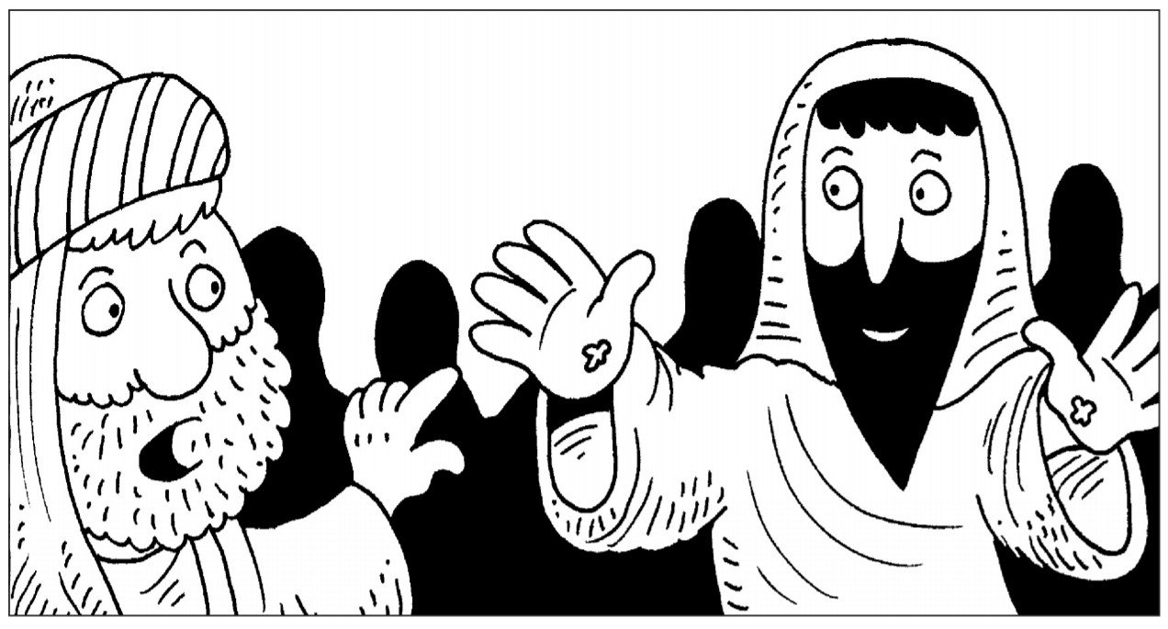
Colour
8
Draw around your hand on paper and cut it out.
Decorate your hand.
Write one thing on each finger that you will do to show kindness to others.

Amazing Breakfast!

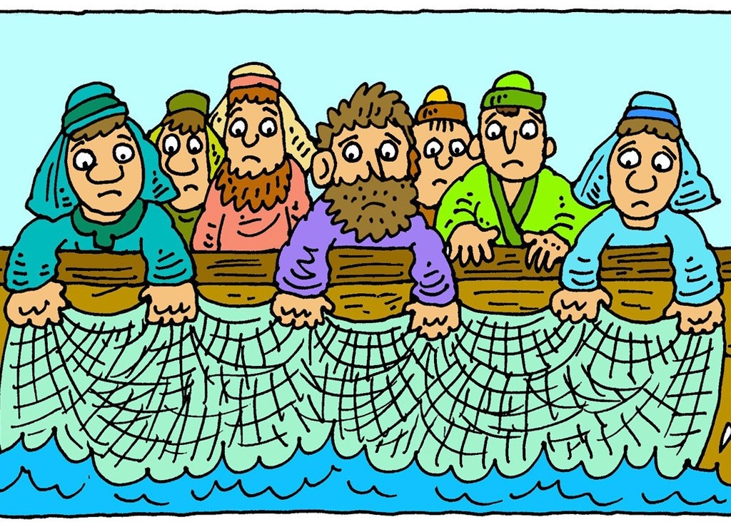
Simon Peter, Thomas, Nathanael, James, John and two other disciples were together by the sea of Galilee. 'I'm going out to fish,' Simon Peter told the others and they said they would go too. So they went out in the boat and fished all night, but caught nothing.

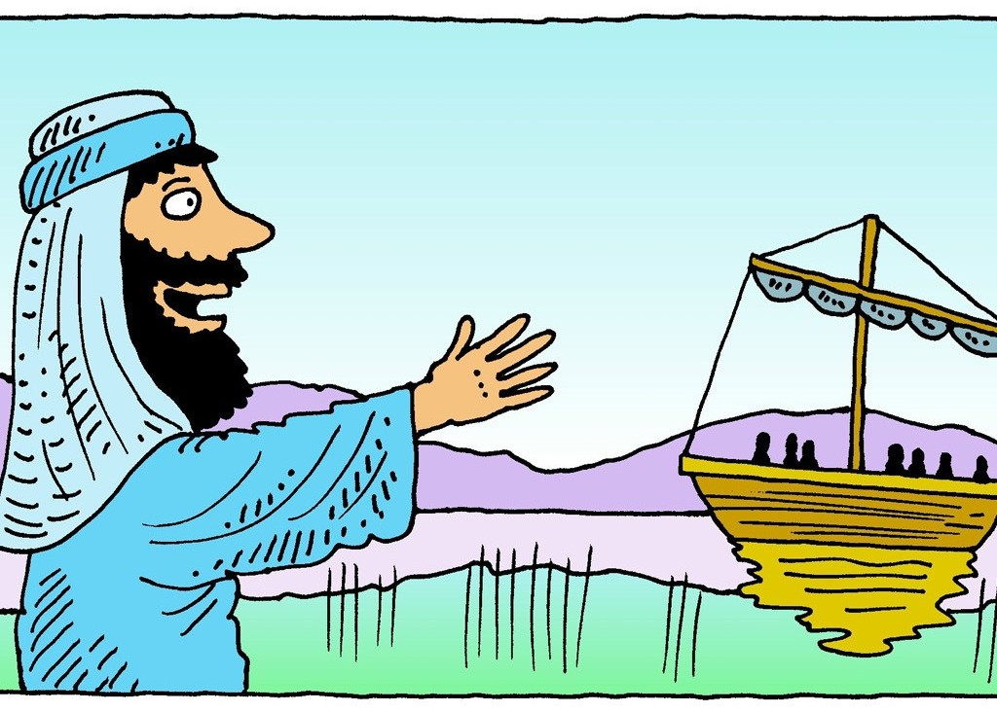
The next morning, Jesus appeared on the shore, but the disciples didn't know it was Him. Jesus called out to them, 'Friends, have you caught any fish?'
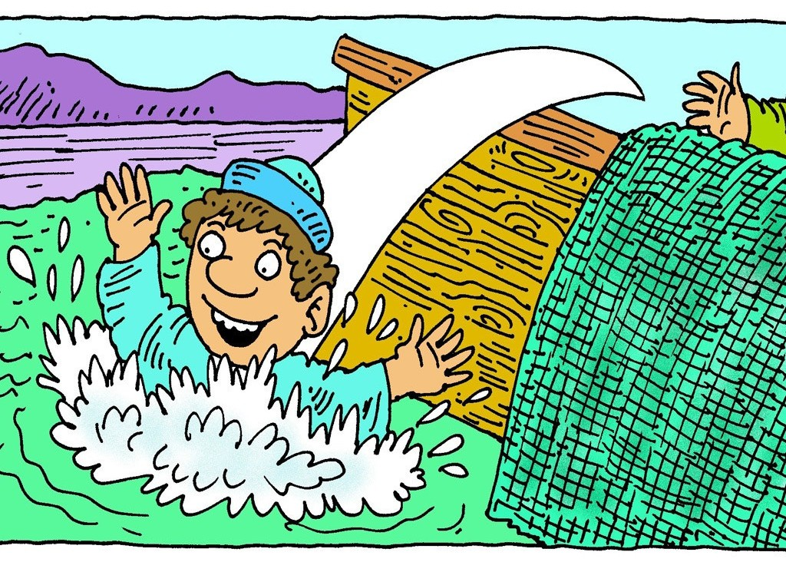
'No,' they answered Him. 'Put your net on the other side and you will find some,' Jesus told them. They did and caught so many fish they could not pull the net in!

Then John realised that it was Jesus! 'Peter! Look! It is the Lord!' he shouted. Peter put on his fishing jacket, jumped into the water and swam to the shore. He was so excited to see Jesus. The other disciples followed in the boat, towing the net full of fish behind them.

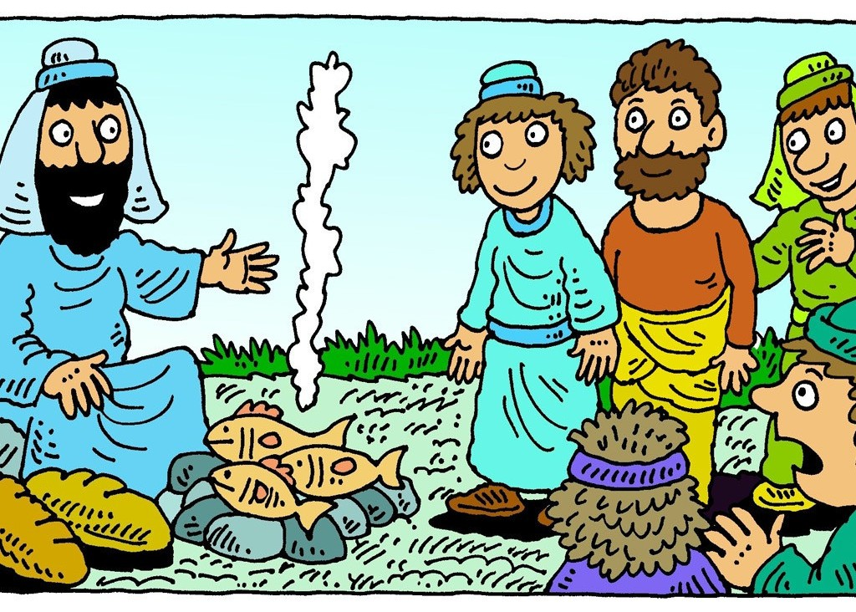
When they landed they saw a fire burning, with some fish on it and bread. Jesus said to them, 'Bring some of the fish that you have just caught.' So Simon Peter dragged the net ashore. It was full of large fish, but even with so many the net remained untorn. Jesus said to them, 'Come and have breakfast.' The disciples knew it was Jesus and they shared breakfast together.
9

Story images from www.freebibleimages.com by www.lambsongs.co.nz

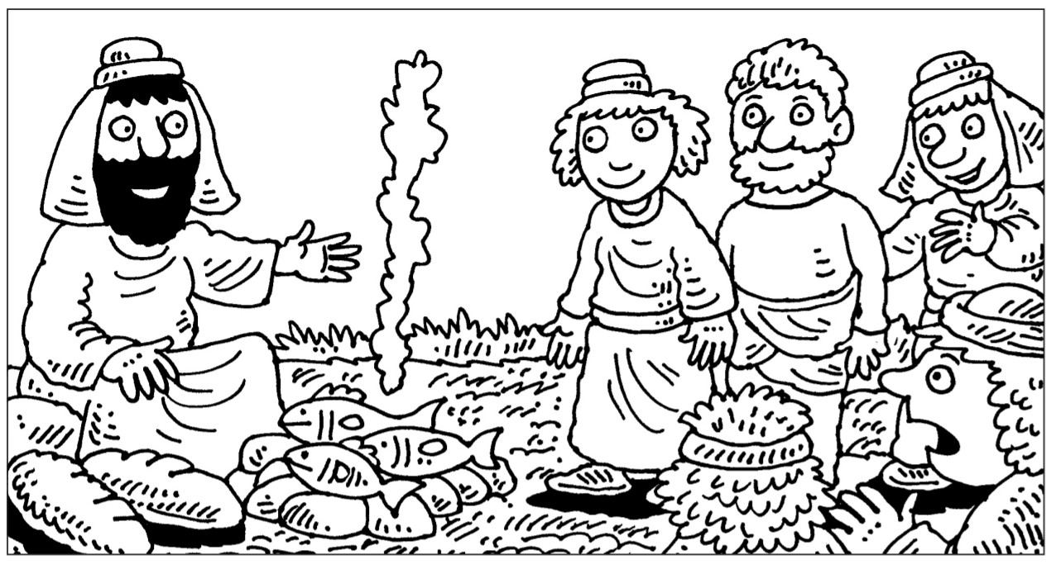
Colour

Word Search
The Bible says that this was the
third time Jesus had appeared to the disciples after his death. Only John recognised Jesus in the dim morning light.
How did Jesus help them to recognise and remember him? Do we forget Jesus sometimes? How do you think Jesus helps us
to remember him?
By taking part in Holy
Communion, Jesus invites everyone to his table for forgiveness and renewal, especially those who are far from him or have forgotten his love, and his hope for us is that we would do the same for others.

BOAT
FIRE
SHORE

FISH
SEA BREAD GALILEE
JESUS
WATER
10

The Ascension

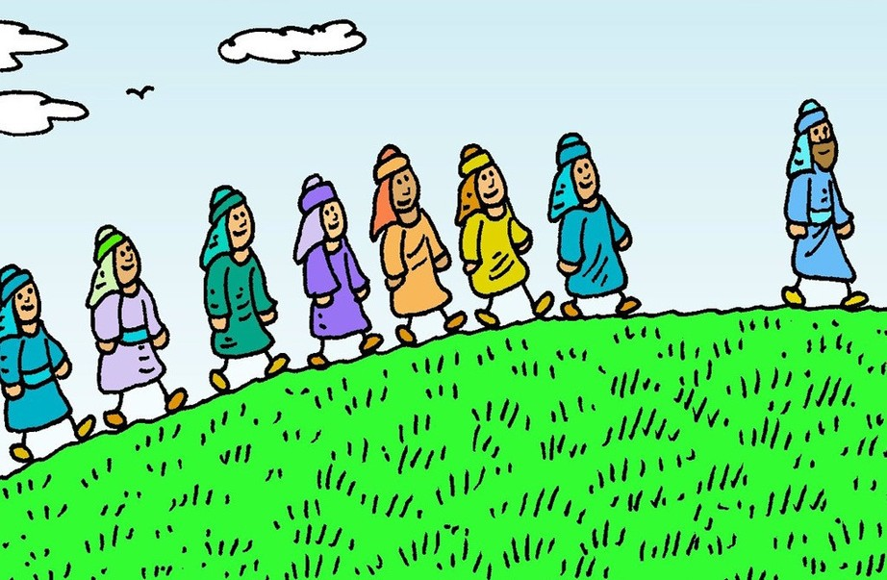
Forty days after Jesus had risen from the dead, He told his friends that it was time for Him to go back to the Father in Heaven. He and His disciples climbed to the top of the mount of Olives.

When they reached the top, Jesus told them to wait in Jerusalem for the Holy Spirit to come and give them power. He wanted them to tell everyone that He loved them so much that He died for them.

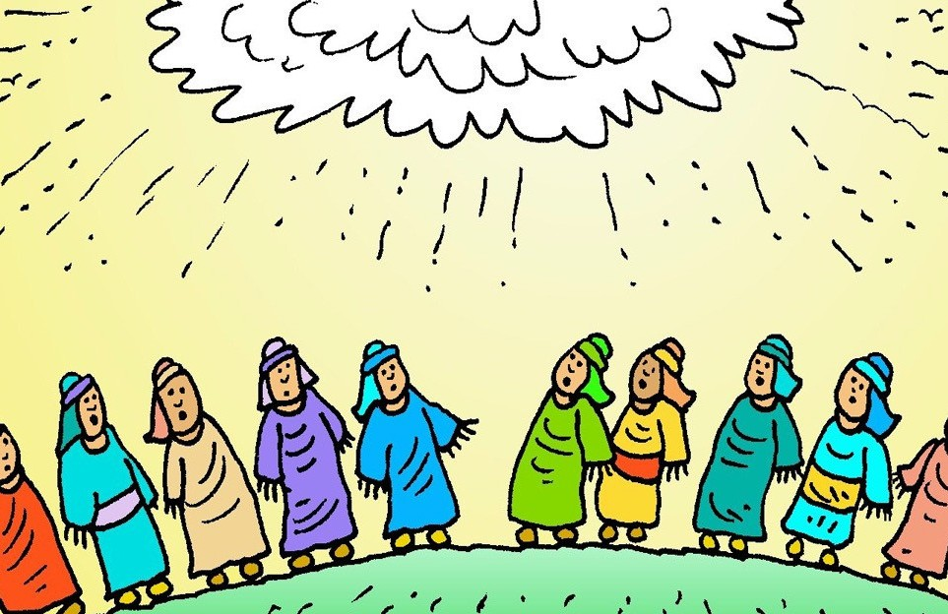
While they were standing there, on top of the hill, the sky was filled with a dazzling light and He was lifted up. A cloud took Him out of their sight. They were so surprised and amazed! They had seen Jesus go up to Heaven with their very own eyes!

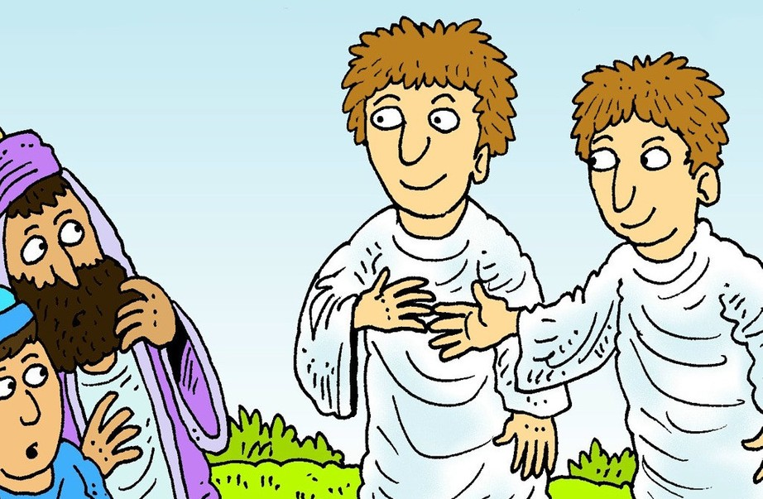
Suddenly, two men in white robes appeared next to them. They said, 'Men of Galilee, why do you stand looking up towards Heaven? This Jesus who has been taken from you into Heaven, will come back one day in the same way you saw Him leave!'

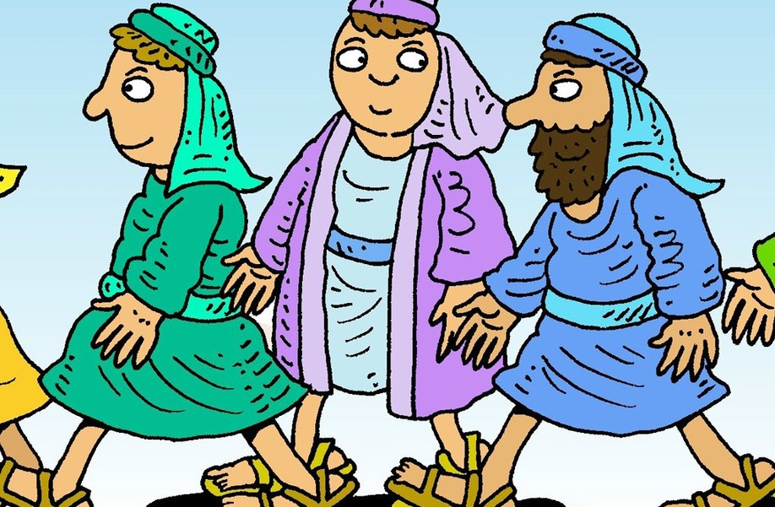
Jesus' friends went straight back to Jerusalem, to wait for the Holy Spirit to come just as Jesus had asked them to do.

Story images from www.freebibleimages.com by www.lambsongs.co.nz
11

Jesus' friends would miss
having Jesus walk with them and being able to see His face.
Very soon God would be sending the Holy Spirit to them. The Holy Spirit will always be with them and go wherever they go. The Holy Spirit would give them power to do the important job of sharing the Good News with other people.
Jesus has not left us alone
either. He has not abandoned us. We will never be alone and wherever we go, Jesus goes with us. If we ever feel sad, alone or confused,
Jesus is with us.

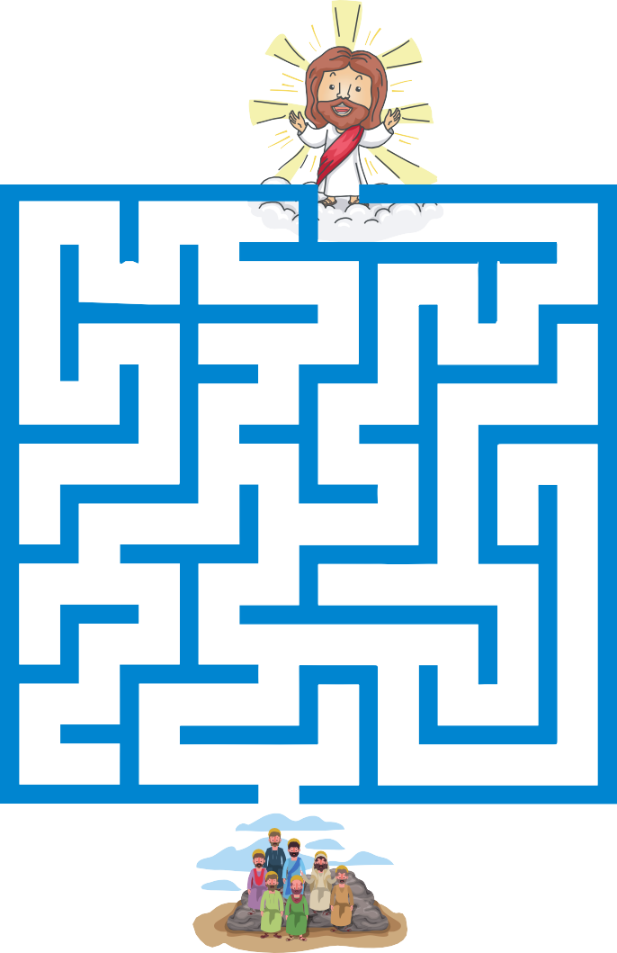
Colour

Maze
Guide Jesus' friends through the maze to the top of the hill, so they can see him go to Heaven.

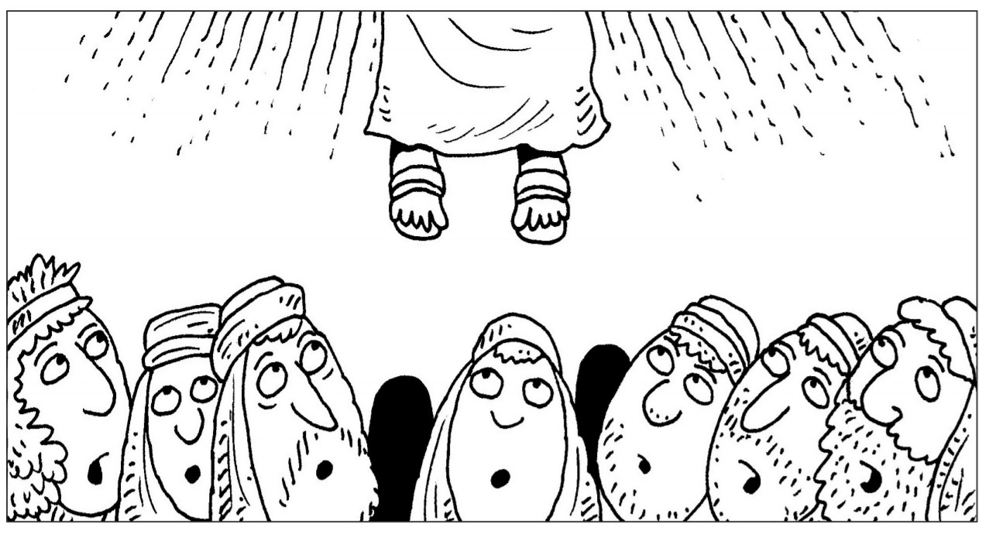
12

Pentecost - The Holy Spirit

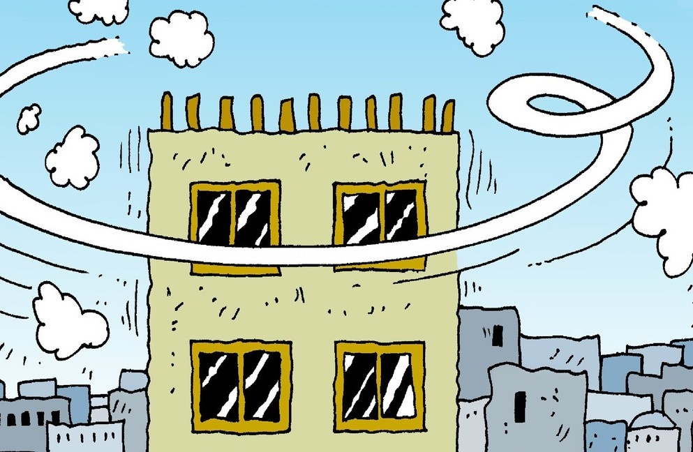
Jesus' friends went back to Jerusalem just as He had told them to. They met together in an upstairs room of a house and waited. They were wondering how Jesus could always be with them, when he had gone! Suddenly they heard and felt a strong wind, which filled the whole house!

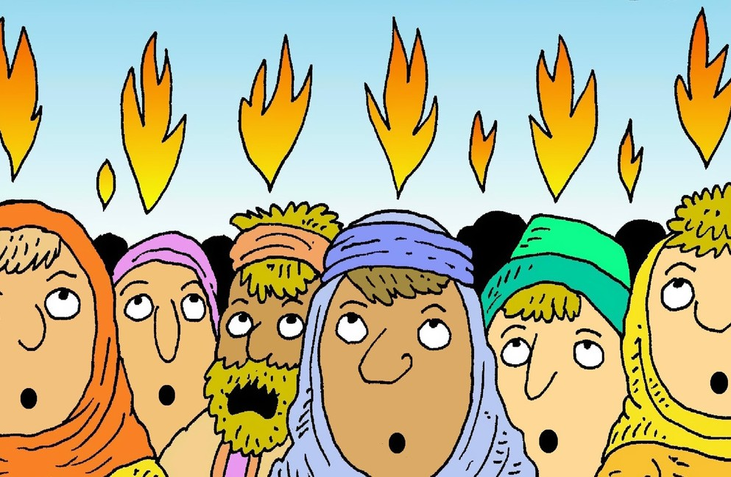
It was the Holy Spirit! Tongues of fire appeared and flickered over their heads and they were filled with the Holy Spirit. It felt like God was right there with them. The flames were bright and their hearts were full of God's love and they praised God.

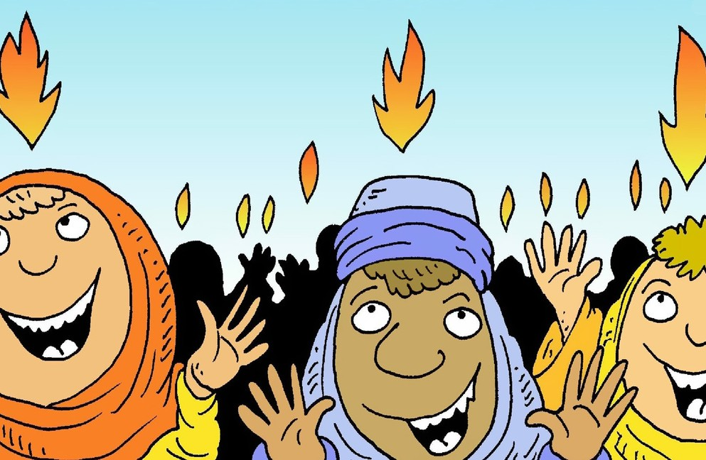
Suddenly Jesus' friends could speak in any language without learning it! The power of the Holy Spirit melted away all their fear and filled them with God's love. They wanted to tell everyone about Jesus.

They rushed outside and spoke to the crowd of people. There were people from other countries and they spoke to them in their own language. They told them that Jesus had risen from the dead and that he loved them.
Everyone in the crowd understood.

The Holy Spirit coming to them was the beginning of something new. Many people in the crowd believed and became followers of Jesus. The wonderful news began to spread through villages, towns and cities and more and more people believed.
13

Story images from www.freebibleimages.com by www.lambsongs.co.nz

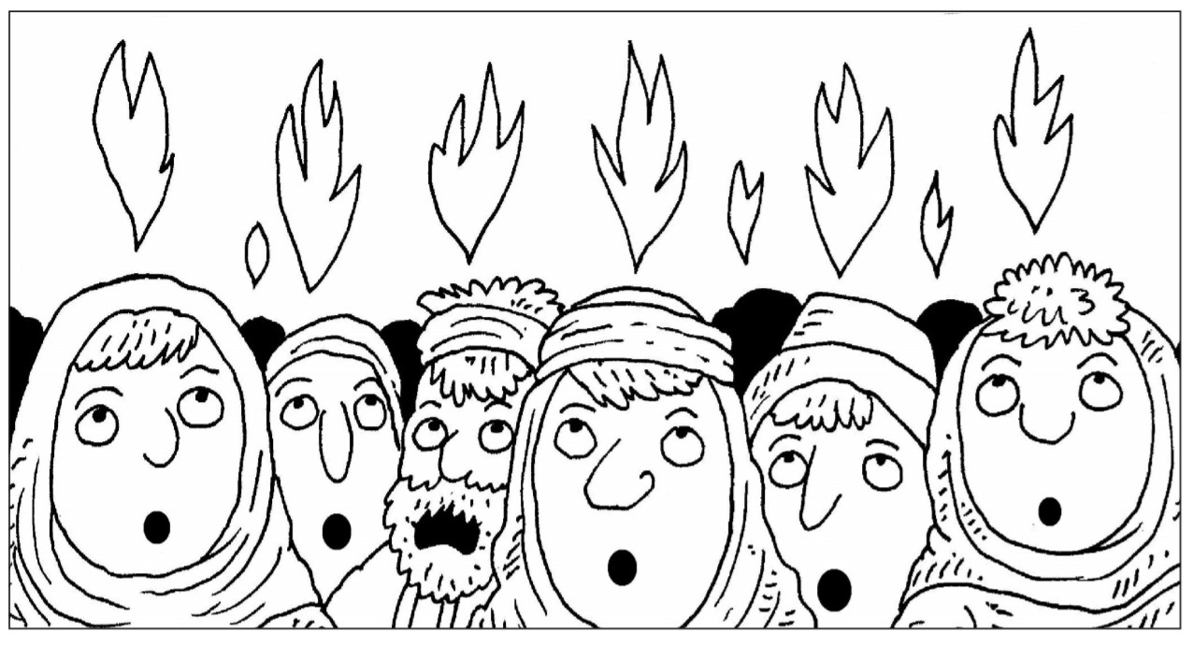
Colour

Following Jesus and being a Christian is not limited to a particular group of people. It doesn't matter who you are, where you are from or what language you speak. God works all kinds of miracles to spread the message of the Gospel, using many languages as He calls all kinds of people to become His followers. No matter who you are.
God speaks to all of us.
Are you listening?

W N I D

3

I F E R
2

8 1 4

S I R I T P

Mystery Word
Rearrange the letters opposite to make words from the story.
Put the numbered letters into the boxes below to work out the mystery word.

S E K P A
5

C D O R W
6 7

1 2 3 4 5 6 7 8
14

