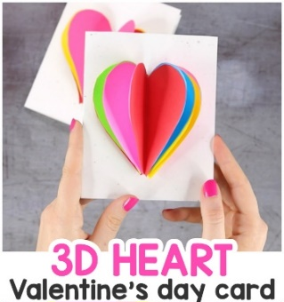
Using your heart template and the coloured paper cut out at least 6 hearts.
Stick one of the hearts on your card. Fold all the other hearts in half.
Apply glue to your heart and stick on 2 half hearts. Continue sticking on half hearts until you have 1 left.
Stick your final heart across both heart halves.
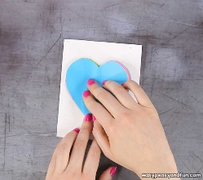
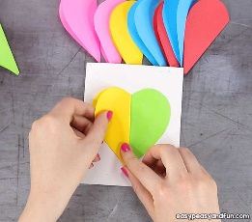
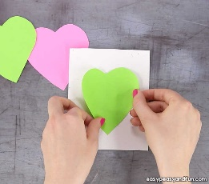

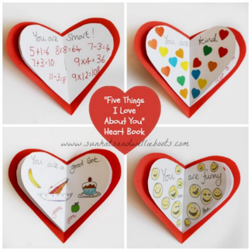
You could write all the things you love about the person on each heart.

There are some other resources in your bag for you to design your own Valentine’s card and some treats you might like to give as a gift.

