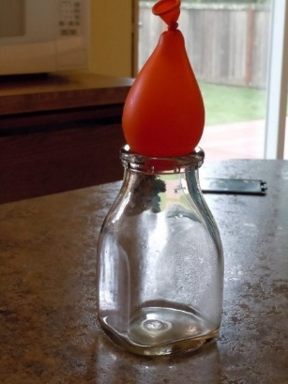
Find a glass bottle with a smaller opening at the top. We then fill a balloon with water to a little larger than the opening of the jar. Rub a little water around the rim of the bottle and try and push the balloon into the bottle. You can’t. But there is a way for the balloon to get sucked into the bottle. Intrigued? Light a small strip of paper on fire and dropped it into the bottle. Put the water balloon on top of the bottle and watch as the balloon is literally sucked into the bottle like magic.
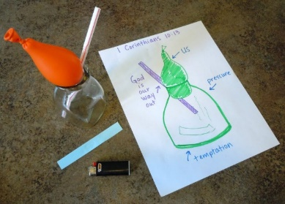
The physics: the warmer air on the inside of the bottle takes up more room than cool air. Once the fire goes out, after putting the balloon on top of the bottle, the air cools and then takes up less room. That makes more space inside the bottle causing the pressure of the air from the outside to push the balloon into the bottle.
Try it again? You’ll need to get the balloon out. Try to pull it out. No luck? There is one way. A straw! With the balloon still inside the bottle, place the straw inside, grabbed the tip of the balloon and pull.
The balloon got caught in the mouth of the bottle because no air could get around it. But, when you add the straw, it let air into the bottle. The air pressure on the inside and the outside stayed equal allowing us to pull the balloon out.
Here is the biblical truth. Ready? The balloon represents you and me. The fire and pressure on the inside of that bottle are like the literal pressure and temptation we encounter each day of our lives. And the straw is God, always and forever providing a way out.
1 Corinthians 10:13
The temptations in your life are no different from what others experience. And God is faithful. He will not allow the temptation to be more than you can stand. When you are tempted, he will show you a way out so that you can endure.

