Directions for Making Popsicle Stick Catapults
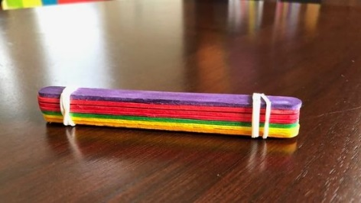
1. Make a stack of 5 popsicle sticks and use rubber bands to tie them together on both ends.

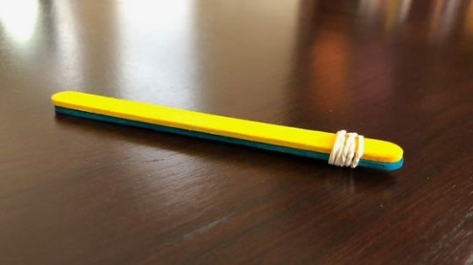
2. Take two additional popsicle sticks and stack them together. Rubberband them together on just one end.

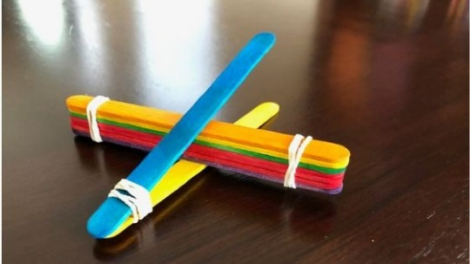
3. Pull the two popsicle sticks slightly apart and wedge the larger stack of popsicle sticks in between them. You may need to rubber band the stack of lolly sticks to the upper stick.

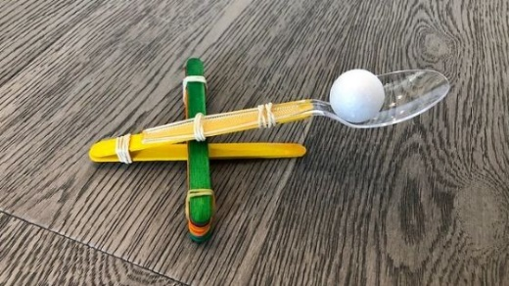
5. Use two rubber bands, secure the plastic soon to the upper popsicle stick.

6. Place a pom pom onto the spoon. Hold the catapult with one hand, and use the other hand to pull the spoon down. Release the spoon to launch your pom pom!

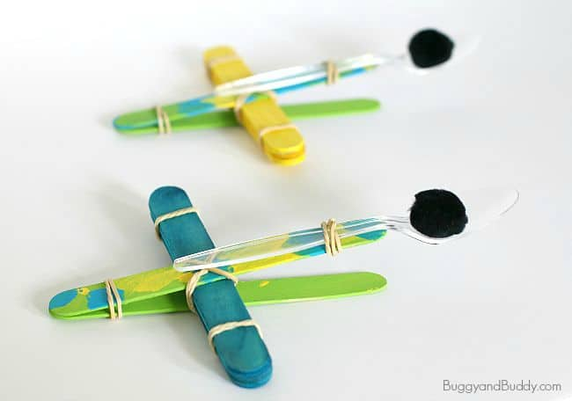
https://www.mombrite.com/popsicle-stick-catapult/

